Reception Summer 2 Curriculum Overview
Sparking an interest in: Superheroes Big Question: How can they help us?
The following is a summary of the focused activities we will be carrying out this term in addition to child initiated learning.
Texts we may read this term
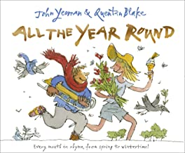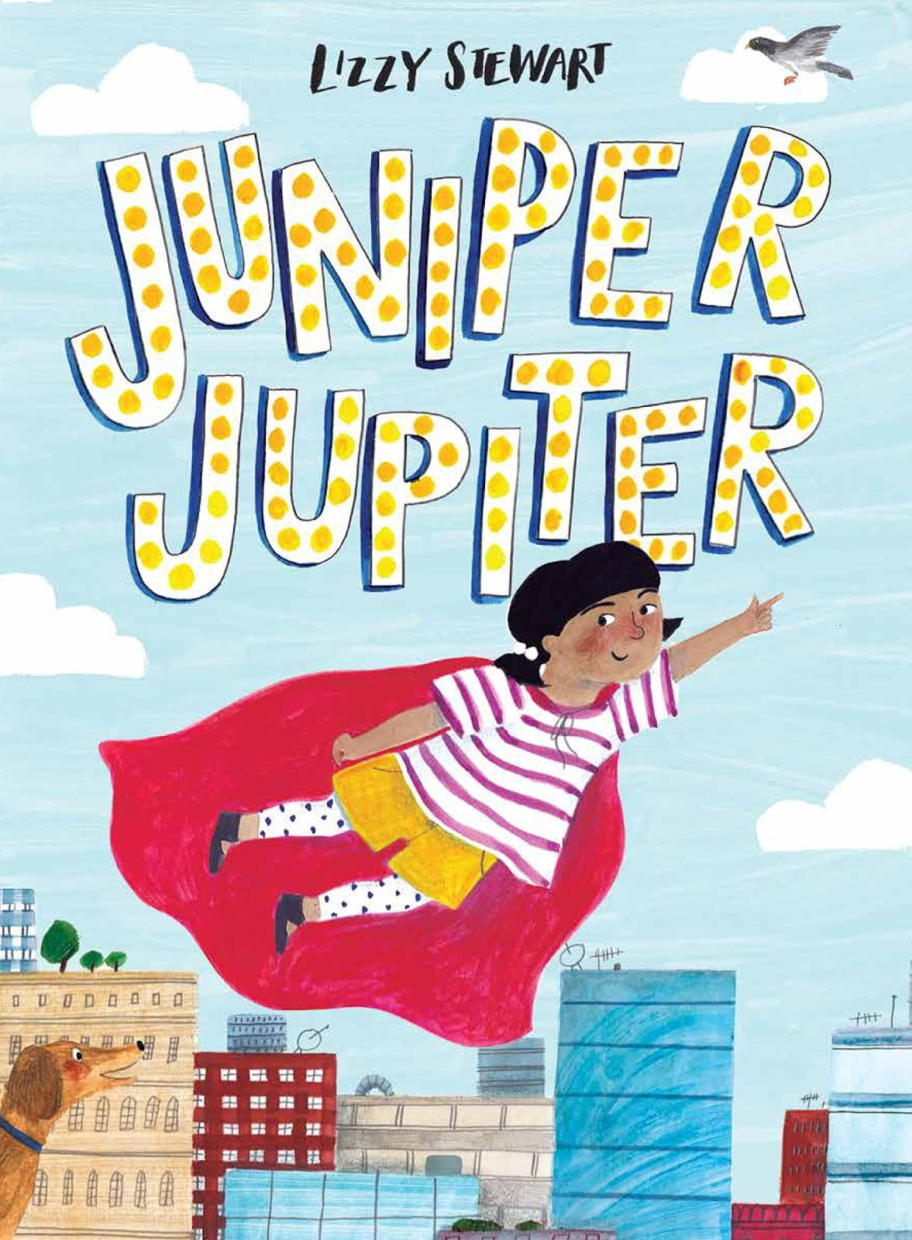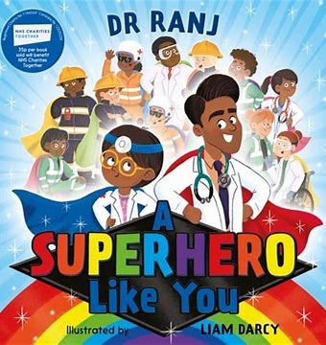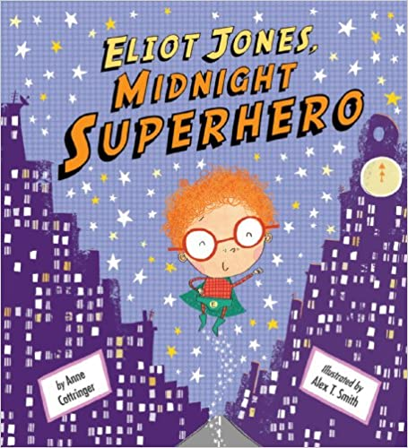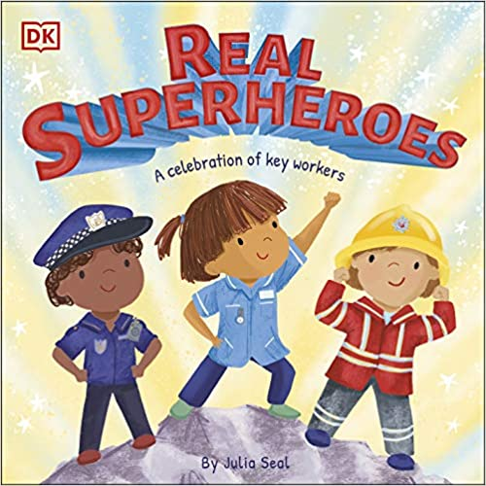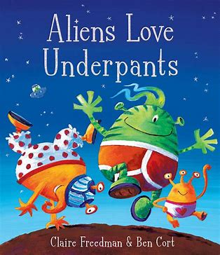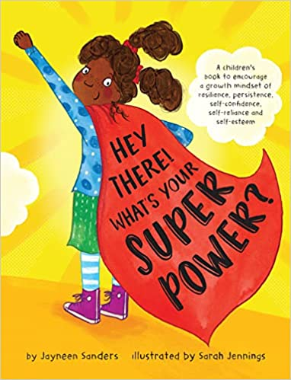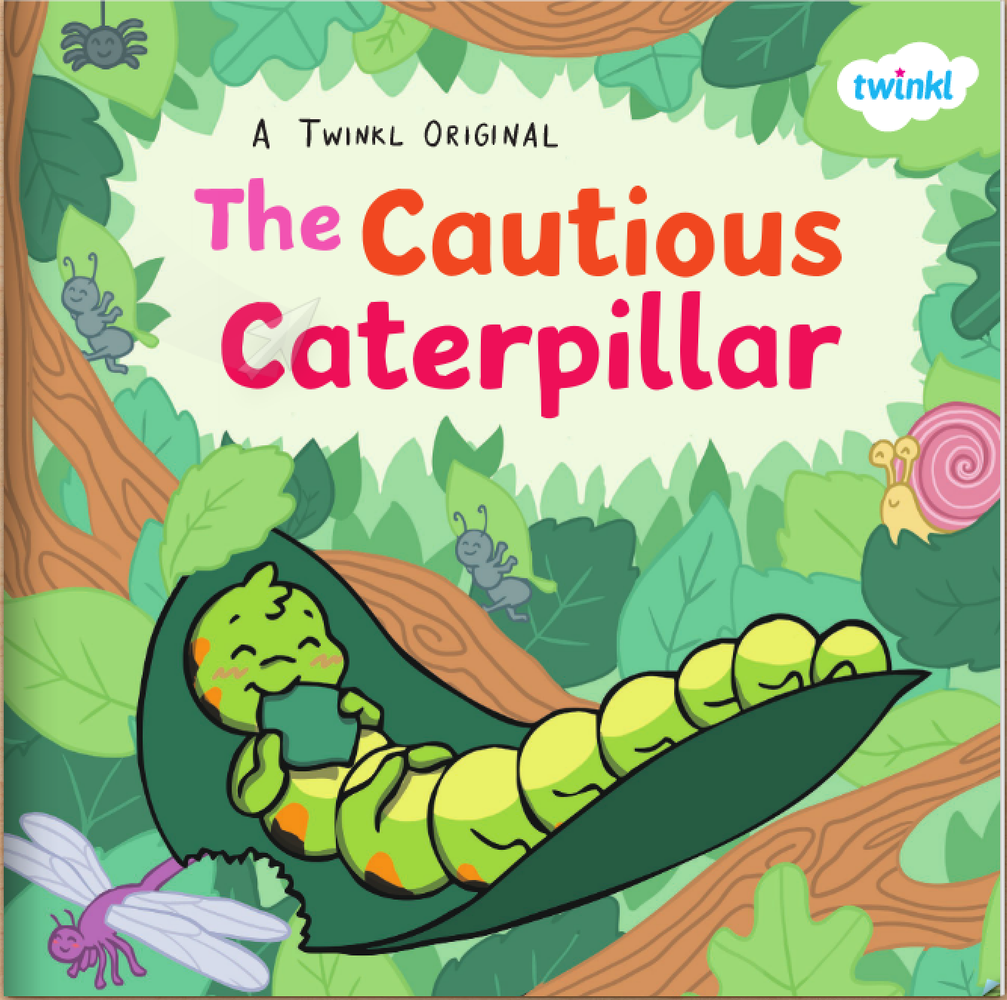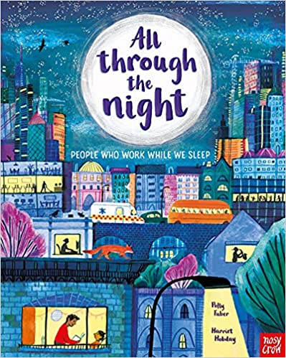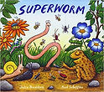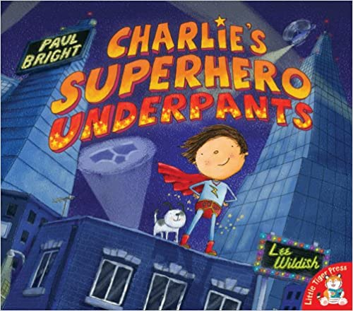

Physical Development
This term in PE our topic focus unit is ‘Superheroes’.
We will continue to follow instructions with consistency. We will move with confidence in space and whilst travelling over apparatus. As we learn to develop our skills with throwing and catching we will focus on correct hand positions for an effective catch and look at using different types of throws.
During outdoor learning we will continue to develop our body strength, using our gross motor skills to build, using large equipment. We will push ourselves physically with challenges such as jumping higher and running faster.
We will further develop our fine motor skills by continuing to use different tools competently, safely and confidently. We will develop our handwriting styles by practicing our letter formations daily.
Personal, Social and Emotional Development
This term we will focus on keeping ourselves safe and how we can support our own health and wellbeing. We will begin to learn about how our bodies belong to us with help from Pantosaurus and the PANTS rules, listening to story Aliens love underpants.
We will begin to look at setting our own goals and how we can achieve them, building a growth mindset where we believe we can do it and enjoy being challenged.
We will look closely at co-operation and why it is important by completing group activities.
We will begin to discuss moving to year 1, listening to stories about change and our feelings. We will be spending some time in our new classroom and meeting our new teacher.
Communication and Language
This term we will listen to new and exciting stories about fictional superheroes as well as stories and fiction texts about real life super heroes.
We will spend time discussing as a whole class and in small focus groups, sharing our ideas and feelings about stories we have listened to.
We will engage in non-fiction texts about people who help us, learning about their roles and taking on these roles in our play.
As we share our experiences, we will be encouraged to use the correct tenses in our sentences such as past, present and future supporting children to extend their sentences.
We will listen attentively, responding to what we have heard with relevant questions and responses.
We will continue to learn new songs and listen to poems during story time and music.

Religious Education
Big Question: Where do we belong?

This term our theme is Being Special. We will be learning about what makes us special and unique and thinking about times when we have felt special.
The children will explore the themes of belonging and community by finding out how we are all unique and special. They will learn about how children are welcomed into faith communities by exploring Christian infant baptism, The Islamic Aqiqah ceremony, a Humanist naming ceremony and Raksha Bandhan.

Literacy
This term we will continue with our level 4 phonics. This level introduces clusters of sounds and will consolidate all level 3sounds within longer words as well as recapping all tricky words and introducing new ones.
During phonics we will continue to write captions and short sentences throughout the week, focussing on remember our sentences, counting the words and taking our time to write each word, hearing all the sounds.
During our literacy lessons we will read and write about the stories we have read. We will become our own superheroes, designing and creating our outfits and super powers. We will challenge ourselves with our writing becoming more independent with less scaffolding when writing simple phrases.
We will continue to read daily, practicing our blending and identifying letter groups that make one sound. During our guided reading, we will focus on comprehension of stories, demonstrating our understanding of what has been read to us and begin to anticipate key events.
Phonics
Level 4 – Tricky Words: said, so have, like, come, some were, there, little, one do, when, out, what
Mathematics
During this half term, we will move start with our topic ‘Find my Pattern’. We will learn about patterns in numbers such as doubles, understanding that ‘it’s twice as many’. We will begin to identify odds and evens, noticing how some numbers can be shared and others can’t as well identifying pairs in numbers with some left over. We will look at sharing and grouping, we will share out items fairly and notice when there are some left over and also begin to group objects into equal groups. We will develop our spatial reasoning skills by looking at models, places and constructions and replicating them building our knowledge about positioning and discussing where items need to be placed, encouraging positional language.
Our last topic is ‘On the Move’ where we will spend time engaging in extended problem solving and continue to develop our critical thinking skills. We will be encouraged to review and discuss our strategies to solve problems. We will continue to explore and investigate patterns and relationships between numbers and shapes.

Understanding the World
This term we are focussing on superheroes around us.
We will learn about people who help us, understanding their roles in the community and how they can help us. We will look at significant people from the past such as Mary Seacole and Florence Nightingale and compare roles from the past to present roles in the community. To help us learn about the different roles we will have opportunities to speak to real life police officers.
We will begin to look at seasonal changes, observing the changes between Spring and Summer. We will discuss the weather daily and how it is changing. We will begin to look at weather in other countries to compare.
We will continue to use ICT to support our learning. We will use laptops to explore purple mash activities linked to our learning. We will use bee-bots to instruct superheroes where to go and how to get there. As well as using the ipads to take pictures and play interactive games.
We will go on our first school trip, exploring a new environment and looking at maps of where we are going.

Expressive Arts and Design
This term we will use our topic of Superheroes to get creative. We will design, and make using a variety of different tools and techniques.
We will listen to many superhero stories which will inspire us to think about our own super powers. We will create our own superhero capes and masks, reflecting on the process of our creations, sharing our ideas with others.
During music this term we will practice all the songs we have learnt so far this year and begin to work in groups to perform them to the rest of the class. We will continue to practice using the musical instruments alongside singing songs and playing copyback games.
We will change our role play area’s into places that belong to superheroes such as doctors surgery or a fire station depending on our interests to support our role play and understanding of roles in our community.
We will create our own superhero stories with our friends and act them out.

School Values
Our school values this term are Co-operation and Peace.
As we learn about Co-operation we will discuss how important it is to work together. We will begin to understand how working together means giving the same effort. We will then focus on Peace and what it means, Learning about how peace enables freedom from disturbance and being calm.

