Reception Summer 2 Curriculum Overview
Sparking an interest in: Superheroes Big Question: How can they help us?
The following is a summary of the focused activities we will be carrying out this term in addition to child initiated learning.
Texts we may read this term
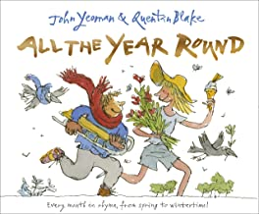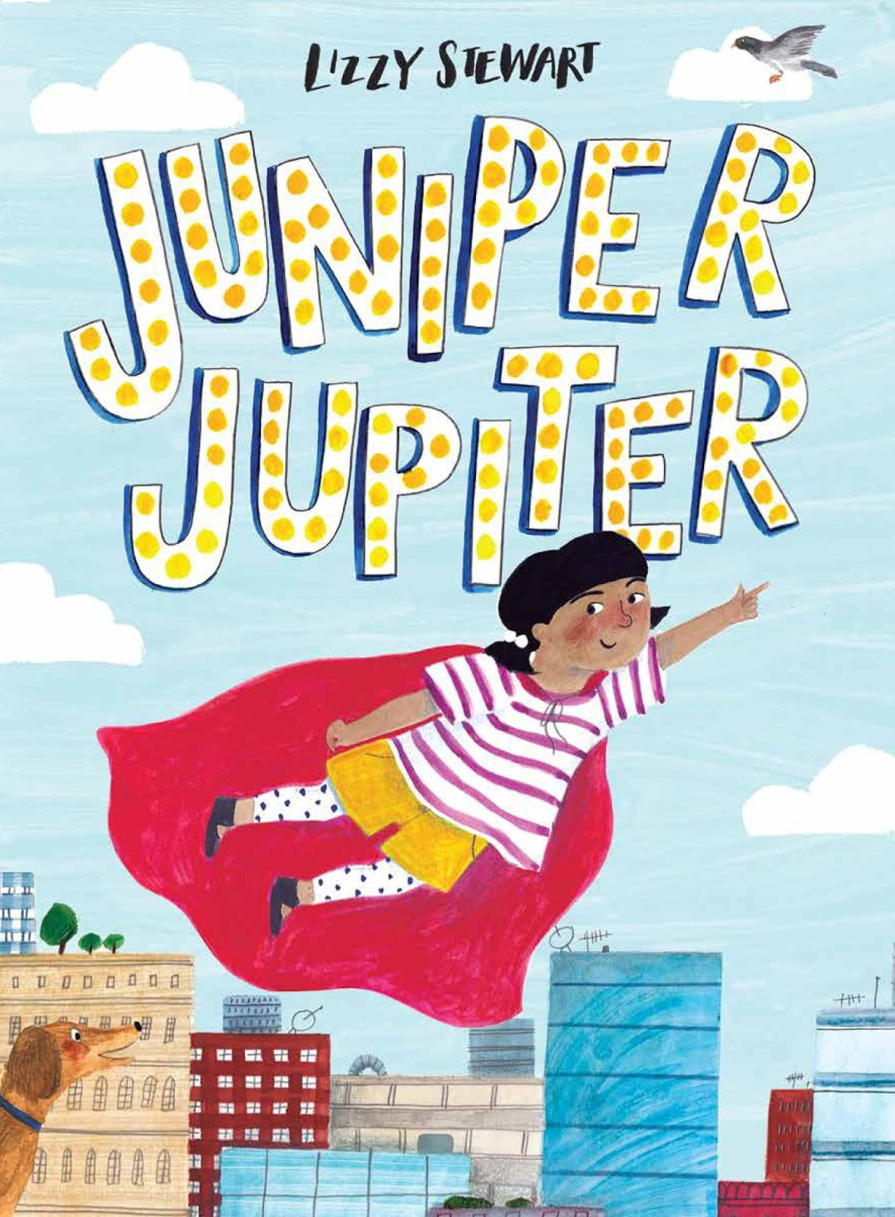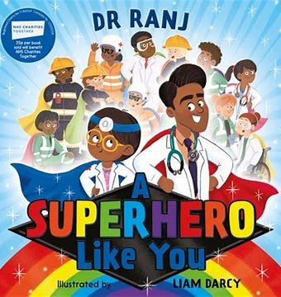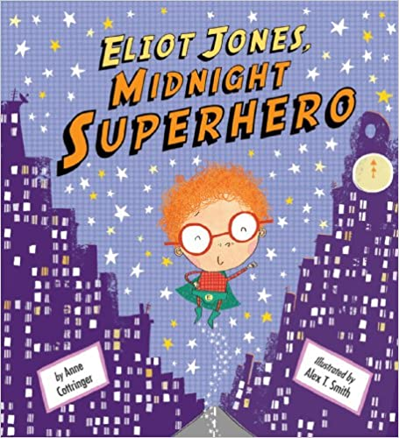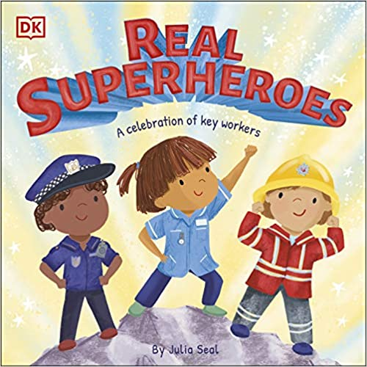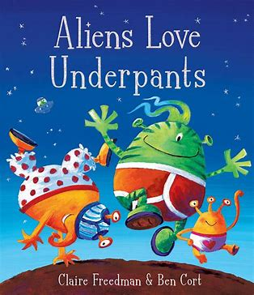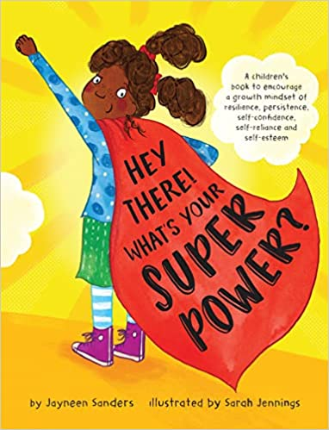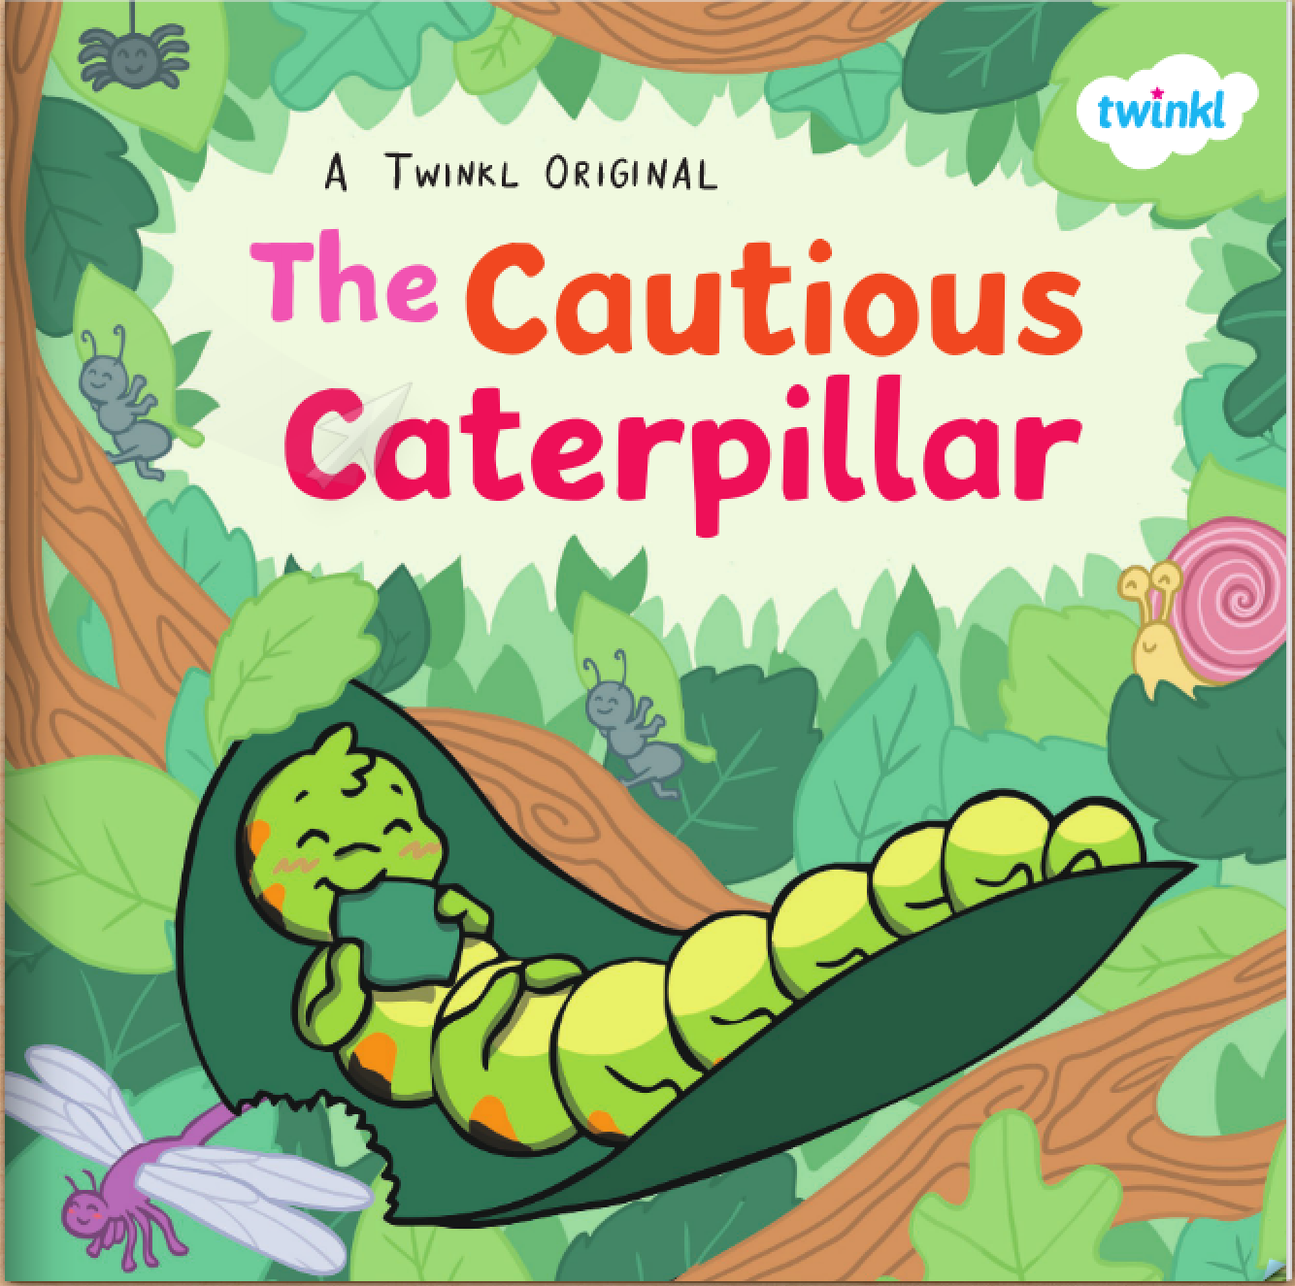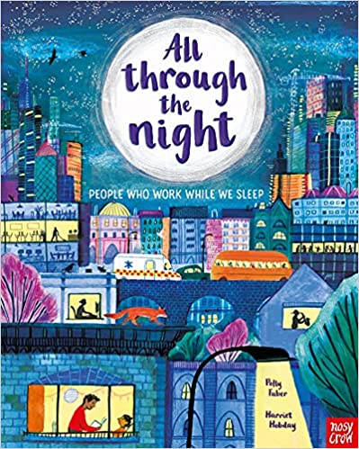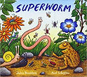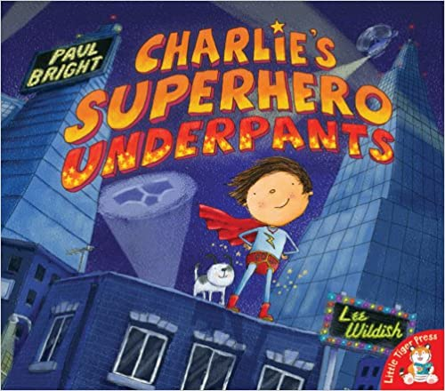

Physical Development
This term we will practise and further develop our movement skills through our topic ‘around the world’. We will learn skills by playing a variety of games. We will learn how to work as a team, take turns, keep the score, play against an opponent and play by the rules.
During outdoor learning we will continue to develop our body strength, using our gross motor skills to build, using large equipment. We will push ourselves physically with challenges such as jumping higher and running faster.
We will develop our fine motor skills by continuing to use different tools competently, safely and confidently to create in art and design.
We will develop our handwriting styles by practicing our letter formations daily to support our writing.
We will join in with Sports day, taking part in teams and working together to compete in different games, learning new skills as we practice and prepare.
Personal, Social and Emotional Development
This term we will look at ‘Changing Me’ as our last piece of Jigsaw. We will explore how we can cope positively with change.
During this topic we are encouraged to think about how we have changed from being a baby and what may change for us in the future. We will consolidate the names and functions of some of the main parts of the body and discuss how these have changed. We will learn that our bodies change as we get older in lots of different ways. We will begin to understand that change can bring about positive and negative feelings, and that sharing these can help us. We will also consider the role that memories can have in managing change.
Communication and Language
This term we will listen to new and exciting stories about fictional superheroes as well as stories and fiction texts about real life super heroes.
We will spend time discussing as a whole class and in small focus groups, sharing our ideas and feelings about stories we have listened to.
We will engage in non-fiction texts about people who help us, learning about their roles and taking on these roles in our play.
As we share our experiences, we will be encouraged to use the correct tenses in our sentences such as past, present and future supporting children to extend their sentences.
We will listen attentively, responding to what we have heard with relevant questions and responses.
We will continue to learn new songs and listen to poems during story time and music.

Religious Education
Big Question: Where do we belong?

This term our theme is Being Special. We will be learning about what makes us special and unique and thinking about times when we have felt special.
The children will explore the themes of belonging and community by finding out how we are all unique and special. They will learn about how children are welcomed into faith communities by exploring Christian infant baptism, The Islamic Aqiqah ceremony, a Humanist naming ceremony and Raksha Bandhan.

Literacy
This term we will continue with our level 4 phonics. This level introduces clusters of sounds and will consolidate all level 3sounds within longer words as well as recapping all tricky words and introducing new ones.
During phonics we will continue to write captions and short sentences throughout the week, focussing on remember our sentences, counting the words and taking our time to write each word, hearing all the sounds.
During our literacy lessons we will read and write about the stories we have read. We will become our own superheroes, designing and creating our outfits and super powers. We will challenge ourselves with our writing becoming more independent with less scaffolding when writing simple phrases.
We will continue to read daily, practicing our blending and identifying letter groups that make one sound. During our guided reading, we will focus on comprehension of stories, demonstrating our understanding of what has been read to us and begin to anticipate key events.
Phonics
Level 4 – Tricky Words: said, so have, like, come, some, were, there, little, one do, when, out, what
Mathematics
This term we will start with exploring sharing and grouping. We will begin to develop an understanding of sharing by investigating what sharing is and describe equal sharing as fair and unequal sharing as unfair. We will share practically for a purpose by having a number of objects to share between various people or groups. When exploring grouping we will use our knowledge of equal and unequal groups to support us. We will learn that grouping involves dividing a set by placing a certain number of items in each group. We will group for a purpose and divide a set of objects by placing a certain number of them in each group. We will look at odd and even numbers and how these can and cannot be shared and consolidate our learning of finding and making doubles.
We will then return to the concept of repeating patterns. We will deepen our understanding of different patterns, and will begin to develop a secure knowledge of pattern rules and the ability to verbalise our thinking and explain it to others.
We will deepen our understanding of spatial reasoning, developing our thinking as to where objects are in relation to each other, this is the beginning of mapping.

Understanding the World
This term we are focussing on superheroes around us.
We will learn about people who help us, understanding their roles in the community and how they can help us. We will look at significant people from the past such as Mary Seacole and Florence Nightingale and compare roles from the past to present roles in the community. To help us learn about the different roles we will have opportunities to speak to real life police officers.
We will begin to look at seasonal changes, observing the changes between Spring and Summer. We will discuss the weather daily and how it is changing. We will begin to look at weather in other countries to compare.
We will continue to use ICT to support our learning. We will use laptops to explore purple mash activities linked to our learning. We will use bee-bots to instruct superheroes where to go and how to get there. As well as using the ipads to take pictures and play interactive games.
We will go on our first school trip, exploring a new environment and looking at maps of where we are going.

Expressive Arts and Design
This term we will use our topic of Superheroes to get creative. We will design, and make using a variety of different tools and techniques.
We will listen to many superhero stories which will inspire us to think about our own super powers. We will create our own superhero capes and masks, reflecting on the process of our creations, sharing our ideas with others.
During music this term we will practice all the songs we have learnt so far this year and begin to work in groups to perform them to the rest of the class. We will continue to practice using the musical instruments alongside singing songs and playing copyback games.
We will change our role play area’s into places that belong to superheroes such as doctors surgery or a fire station depending on our interests to support our role play and understanding of roles in our community.
We will create our own superhero stories with our friends and act them out.

School Values
Our school values this term are Co-operation and Peace.
As we learn about Co-operation we will discuss how important it is to work together. We will begin to understand how working together means giving the same effort. We will then focus on Peace and what it means, Learning about how peace enables freedom from disturbance and being calm.

