Reception Summer 1 Curriculum Overview
Sparking an interest in: Growing Big Question: What makes it grow?
The following is a summary of the focused activities we will be carrying out this term in addition to child initiated learning.
Texts we may read this term
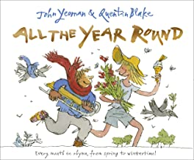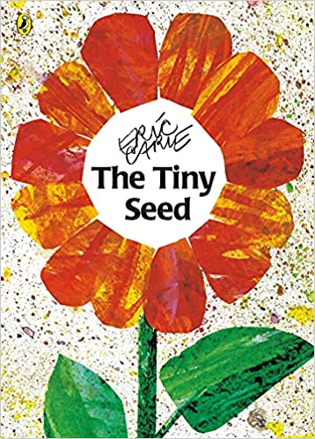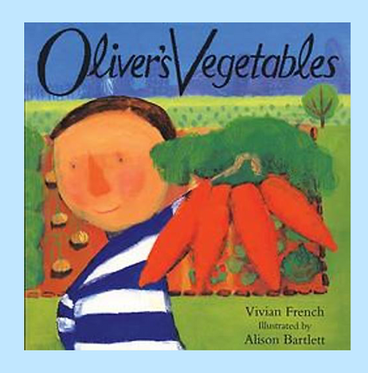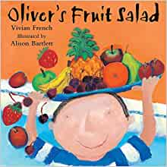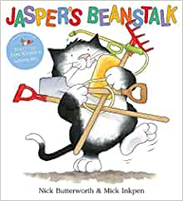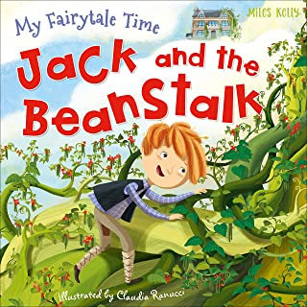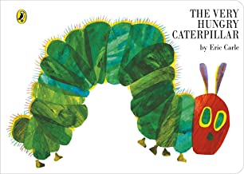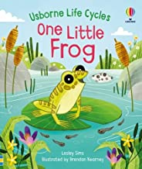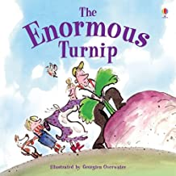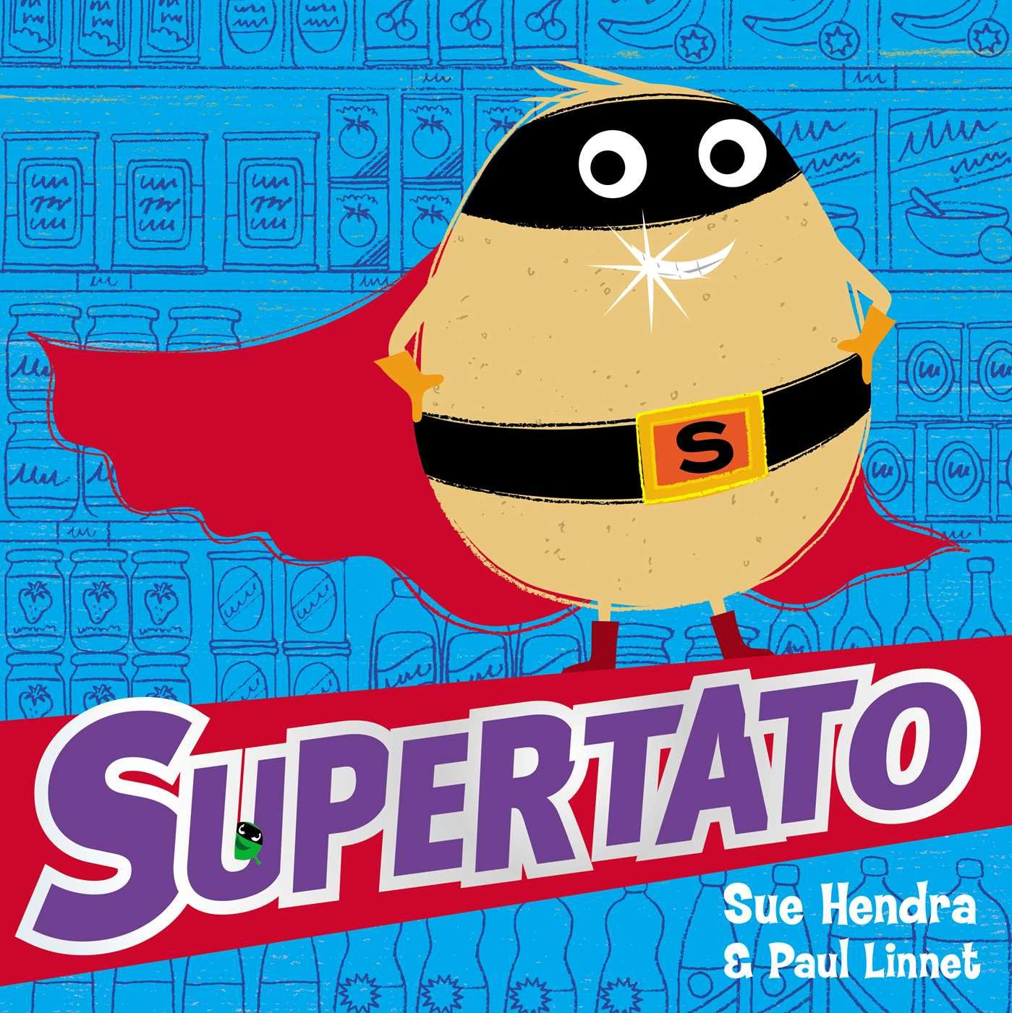

Physical Development
This term in PE we will continue to develop our ball skills through the topic ‘weather’. We will develop fundamental skills such as throwing, catching and bouncing and catching and using targets. We will learn how to dribble a ball using our feet and kicking. We will develop our fine and gross motor skills through a range of game play with balls. We will develop our decision making using simple tactics.
We will develop our movement skills through our topic ‘Places and Spaces’. We will develop skills of balancing, running, hopping and jumping through travelling. We will continue to develop skills through handling different equipment and working with a partner to complete tasks.

Personal, Social and Emotional Development
This term we will look at relationships as our next piece of Jigsaw.
We are introduced to the key relationships in our lives, focussing on our families and friends. We learn about families and the different roles people can have in a family, looking at the ways we help at home and what roles we have.
We will explore the friendships we have and what makes a good friend, learning about how we can be good friends supporting each other.
We are introduced to simple strategies that we can use to mend friendships and how we can try to solve differences more independently.
We will also learn about Jigsaw’s Calm Me and how we can use this when feeling upset or angry.

Communication and Language
This term we will engage in non–fiction books about growing and life cycles to learn new vocabulary linked to our interest in plants and animals. We will share these stories during topic learning time, discussing new language, sharing pictures and using our new knowledge to help explore real plants and the butterfly life cycle.
We will focus on understanding questions such as who, why, when, where and how as we read non-fiction and fiction texts answering questions about what we have read and asking our own questions to find out more.
We will develop our own storylines or narrative into our play, taking on different roles as we act out stories in our own way.
We will use talk to help work out problems and organise our thinking and activities, articulating our ideas in well formed sentences.

Religious Education
Big Question: Which places are specially valued and why?
This term we will be thinking about ‘What makes places special?’ We will talk about somewhere that is special to us, encouraging our explanations and explaining why.
We will begin to recognise that some religious people have places which have special meaning for them and talk about the things that are special and valued in a place of worship. We will begin to recognise that for Christians, Muslims or Jews, these special things link to beliefs about God. We will also get to know and use appropriate words to talk about our thoughts and feelings when visiting a church. express a personal response to the natural world.

Literacy
This term we will consolidate our learning of all level 3 sounds and tricky words. We will then begin level 4 focussing on clusters of sounds, reading and writing longer words and learning new tricky words.
During phonics we will write simple words, focusing on our digraphs and trigraphs to support recognition. We will then form simple captions, building on our confidence to write longer phrases independently. We will begin to look at using a capital letter at the beginning of a sentence.
During our literacy lessons we will read simple phrases in pairs and independently to build on our fluency of reading known sounds. We will match pictures to sentences, identifying and underlining focussed sounds.
We will continue to read daily, practicing our blending and identifying letter groups that make one sound.
As we write independently we will be encouraged to re-read our work and check it makes sense with support.
Phonics – Level 3 - Recapping all sounds and Tricky Words.
Phonics – Level 4 – CVCC and CCVC Words
New Tricky words: said, so, have, some, come, like
Mathematics
As we move on we will continue to practise and consolidate our key skills such as counting, subitising, matching and sorting, comparing and ordering as well as the composition of numbers.
This term we will start with our topic ‘To 20 and beyond’. We will look at counting and building numbers beyond 10. We will notice how larger numbers are made from full 10’s and some ones.
We will focus on number patterns and begin to recognise how numbers 1–9 repeat after every 10. We will practice counting on and back beyond 10 and recognising numbers beyond 10 then 20.
We will then move onto looking at spatial awareness and reasoning. We will focus on selecting the right shapes to fit in spaces and explaining why. We will match arrangements of shape, rotating and using positional language to support us.

Understanding the World
This term we are focussing on growing. We will explore the natural world around us and engage in learning about plants. We will look at local plants as we go on nature walks, learning the names, drawing pictures of them and making close observations. We will grow our own plants, describing the changes that occur and understanding the concept of growth.
We will learn about the key features of the life cycles of animals. We will have hands on experience of watching the life cycle of a butterfly, caring for the caterpillars and learning to respect all living things.
We will begin to look at seasonal changes, observing the changes between Winter and Spring. We will discuss the weather daily and how it is changing and what this means in some of our decisions on what to wear.
During the term we will use different types of technology such as the interactive whiteboard to play games. We will use ipads to take pictures of our environment, looking for changes. We will record videos of ourselves using the ipads to support our performances in music/dance.

Expressive Arts and Design
This term we will use our topic of growing to express ourselves through movement, making ourselves grow and move like different animals and plants, responding to different music. We will look at the Artist Giuseppe Arcimboldo and create collages using fruit and flower images. During music this term our unit is ‘Big Bear Funk’. We will listen to and appraise Funk music. We will embed foundations of the interrelated dimensions of music using voices and instruments, learning to sing Big Bear Funk and revisiting other nursery rhymes and action songs. We will play instruments within the songs we learn as well as improvise using voices and instruments. As we gain confidence we will share and perform songs within class.
As we explore animals and plants we will develop our colour mixing to create representations of what we can see. Refining a variety of artistic effects to express our ideas. We will work together to act out stories such as the enormous turnip and Jack and the beanstalk, extending our imagination by adding in extra characters or changing parts of the story.

School Values
Our school values this term are trust/honesty. During these months we will discuss the importance of trust in positive relationships and how important it is to be honest, to speak up and be truthful and make sure we always do the right thing.

