Reception Spring 2 Curriculum Overview
Sparking an interest in: Animals Big Question: What is my favourite animal and why?
The following is a summary of the focused activities we will be carrying out this term in addition to child initiated learning.
Texts we may read this term
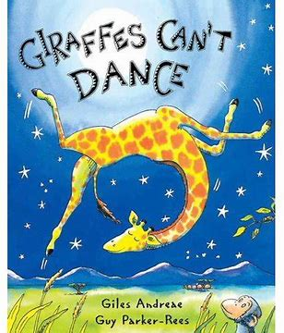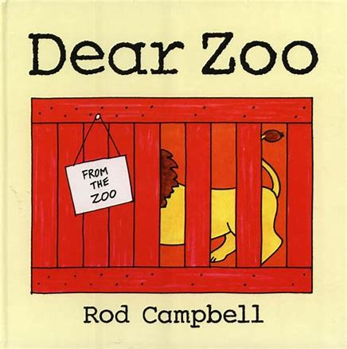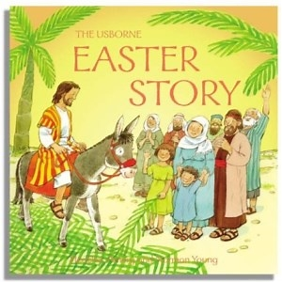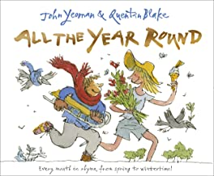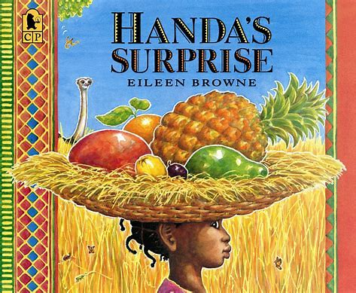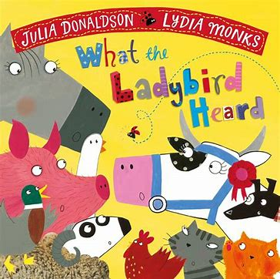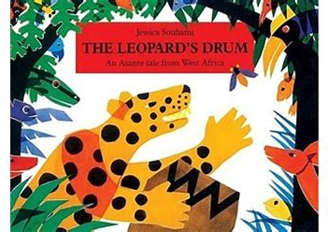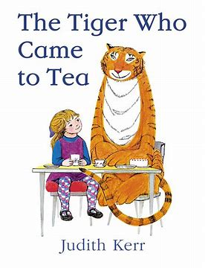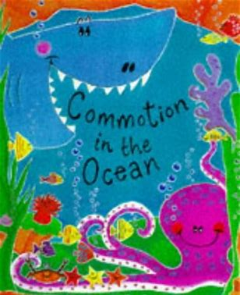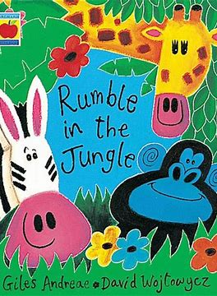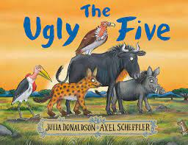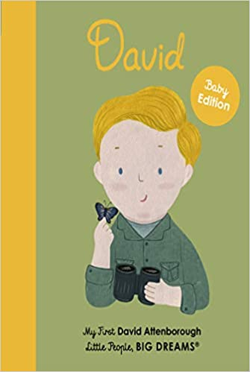

Physical Development
This term in PE we will develop our basic gymnastic skills through our topic ‘Animals and their habitats’. We will explore creating shapes, balances and jumps and begin to develop rocking and rolling. We will show an awareness of space and how to use it to safely to perform basic skills on both the floor and apparatus. We will copy, create, remember and repeat short sequences. We will begin to understand using levels and directions when travelling and balancing.
Through our topic Minibeasts, we will explore ball skills. We will develop skills such as rolling and receiving a ball, throwing to a target, bouncing and catching, dribbling with our feet and kicking a ball. We will develop our fine and gross motor skills through a range of game play using different equipment and will work with a partner.
Personal, Social and Emotional Development
This term we will focus on healthy eating linked to our stories Handa’s Surprise and the Tiger Who Came to Tea. Looking at making healthy choices with our food and why it is important to our health and well-being. We will continue to build respectful and constructive relationships with our peers, cooperating and sharing with each other.
As we challenge ourselves with our writing we will learn about perseverance in the face of challenge. We will have opportunities to tell each other about our work, showing a sense of pride . We will begin to reflect and self-evaluate our own work and have support to develop problem-solving skills by talking through how we and others resolved a problem or difficulty. We will begin to seek ways to manage conflicts with some support.
Communication and Language
This term we will listen to new and exciting stories about different animals. We will focus on key texts and encourage retelling of the stories through role play and literacy work. We will build on our knowledge of the stories identifying main characters and settings. We will learn new vocabulary as we learn all about the different animals in the world, asking questions such as what and where and extending to why. We will listen to and engage in non-fiction books about animals, learning all about different animals in the world, developing a deep familiarity with new knowledge and vocabulary related to our topic. We will engage in poems about Spring and Easter, learning them to perform to our friends and family. We will continue to understand how to listen carefully and why listening is important especially during focussed learning times in small groups.

Religious Education
Big Question: Why do Christians put a cross in an Easter garden?
This term we will be learning about Easter. We will learn that Easter is the most important Christian festival, a time of sorrow, reflection, joy and hope. We will learn about the beginning of Lent focussing on Shrove Tuesday and Ash Wednesday. We will read the story of Palm Sunday and begin to understand the Holy week. We will look at significant symbols of Easter such as hot cross buns, crosses, palm leaves and easter eggs and why these are important to Christians. We will begin to understand what Jesus did and why he important to Christians. We will have our own Easter egg hunt and make hot cross buns to help us celebrate Easter.

Literacy
This term we will continue to learn our level 3 phonics. We will learn about letter groups which make one sound as well as continuing to learn tricky words. We will continue to use our sounds to read and write simple words and phrases.
During phonics we will begin to write short captions to match pictures and continue to practice writing from left to right, leaving finger spaces between new words.
During our literacy lessons we will use our knowledge of our stories to create story maps, lists for food and writing our own ideas for our work.
We will be encouraged to add more writing to our pictures in the creative area to describe what we have created.
We will continue to read daily, practicing our blending and identifying letter groups that make one sound.
Phonics
Level 3 - oo, oo, ar, or, ur, ow, oi, ear, air, ure, er
Tricky Words - was, my, you, they, all, are
Mathematics
This term we will focus on exploring and comparing length and height. We will learn language such as long, longer, short, shorter, tall and taller to compare. We will use a variety of different measuring equipment when looking at a variety of different collections of objects and use the language of length and height to describe them.
We will then move on to deepen our understanding of time, ordering and sequencing events using language such as now, before, later, soon, after, then, next as well as yesterday, today, tomorrow.
We will move on to our topic ‘Building 9 and 10’, where we will find, represent, subitise and compare numbers to 10. We will explore their composition using 10 frames, bead strings and our fingers. Using our new knowledge to explore number bonds to 10. We will deepen our understanding of 1 more and 1 less within 10. We will then move on to learning about doubles to 10, finding them and making them as well as learning about odd and even numbers.
We will complete the term exploring 3D shapes and noticing 2D shapes and extending our knowledge of patterns by making more complex repeating patterns We will describe, create and continue repeating patterns.

Understanding the World
This term we are focussing on Animals. We will explore different groups of animals each week, through stories and non – fiction texts.
We will learn about David Attenborough and his dedication to protecting animals, discussing how animals can become extinct We will begin to understand the need to respect and care for all living things and what we can do to help protect them.
We will read stories which have contrasting environments to compare and discuss, looking at similarities and differences. We will look at where animals live around the world, in different climates to suit them using non -fiction texts to support learning new vocabulary. We will begin to understand that animals live in different places to suit them and that there are different types of animals in the world.
We will begin to look at seasonal changes, observing the changes between Winter and Spring. We will discuss the weather daily and how it is changing.
During the term we will use different types of technology to support our learning. We will use bee-bots, programming them to travel to different places. We will use Ipads and smart boards to explore google earth and maps.

Expressive Arts and Design
This term we will use our topic of animals to help us explore colour, mixing colours to match colours of animals.
We will learn new skills by exploring the sculptural qualities of malleable materials such as clay and develop the use of tools and joining techniques when making our own clay animals. We will create animal pictures using a variety of different materials and effects.
We will listen to the story ‘Giraffes can’t dance and explore different kinds of music. As we listen to different genres we will respond by expressing ourselves through movement. We will also listen to different types of music from around the world such as African dance.
During music this term we will learn new animal songs, finding the pulse in different ways and using our voices to explore high and low. We will explore the musical instruments with music and work together.
We will continue to engage in role play with a new safari lodge outdoor area.

School Values
Our school values this term are hope and imagination. Through our collective worships we will discuss what hope is and share our thoughts and feelings. We will look at imagination and how we can be creative.

