Reception Spring 1 Curriculum Overview
Sparking an interest in: Transport Big Question: Where can we go and how can I get there?
The following is a summary of the focused activities we will be carrying out this term in addition to child initiated learning.
Texts we may read this term
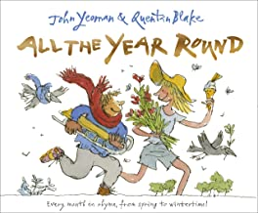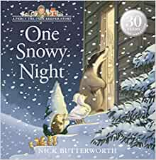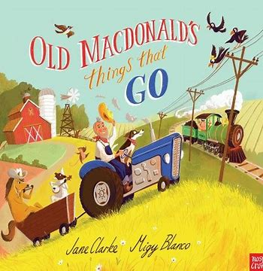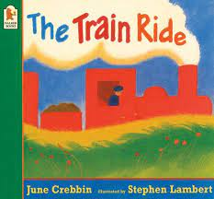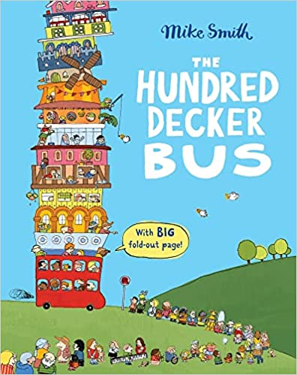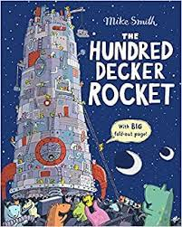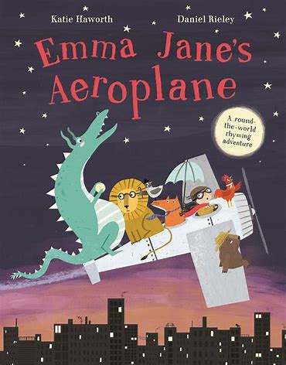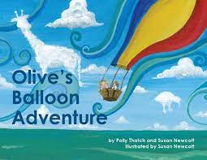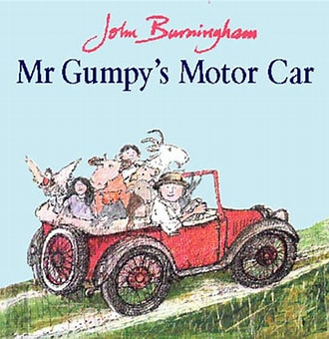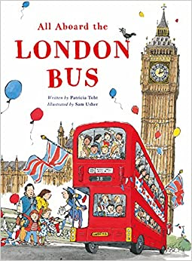

Physical Development
This term our PE Unit is ‘Enjoy a ball’. In this unit, we will experiment with different ways to move a ball in a game using our hands and feet. We will play games, which encourage movement, negotiation of space, listening skills, aiming skills, teamwork and fun competition.
We will also explore some yoga and mindfulness, learning how to balance, hold and move.
This term we will get out the large apparatus to develop our gross motor skills, building on our strength and balance. We will learn how to be safe as well as develop our risk taking. We will experiment different ways of travelling along apparatus.
During outdoor learning we will use gross motor skills to build different vehicles with the large equipment and continue to use our balancing skills on the bikes and scooters.
Personal, Social and Emotional Development
This term we will continue to build respectful and constructive relationships with our peers, cooperating and sharing with each other.
We will learn about resilience and perseverance in the face of challenge. We will have opportunities to tell each other about our work and play. We will begin to reflect and self-evaluate our own work and have support to develop problem-solving skills by talking through how we and others resolved a problem or difficulty.
We will learn that mistakes are an important part of learning and going back is trial and error not failure.
We will continue to learn about the importance of personal hygiene and factors which support overall health and well-being.
Communication and Language
This term we will continue to understand how to listen carefully and why listening is important especially during focussed learning times in small groups.
We will listen to new and exciting stories about different types of transport and go on adventures following them around the world. We will learn new vocabulary linked to our topics, asking questions and retelling the stories through role play and literacy work.
We will listen to and engage in non-fiction books about transport, learning how to use them to find out information about different types of transport developing a deep familiarity with new knowledge and vocabulary related to our topic.
We will engage in poems, looking at the season of Winter and learning them to join in with repeated refrains or verses.

Religious Education
Big Question: What stories are specially valued and why?
This term we will be learning about different stories and why they are valued as being special. To begin we will look at our favourite stories and why they are special to us, sharing our thoughts and feelings with our peers. We will then look at stories from the bible, discussing how this is a special book for Christians and why they are special to Christians. We will also look at other important stories from faiths such as Judaism, focussing on the story of Hanukkah

Literacy
This term we will move on to Level 3 phonics. We will learn about letter groups which make one sound as well as continuing to learn tricky words. We will continue to use our sounds to read and write simple words and begin to write captions with support.
We will design different types of transport to match our core texts this term, writing about our ideas and sharing these with our peers. We will use our sound knowledge to support our writing, practicing our letter formation and making sure we start and finish in the correct positions.
As we share our core texts, we will discuss new vocabulary, engaging in conversations about what words mean.
Phonics
Level 3 - j, v, w, x, y, z, zz, qu, ch, sh, th, ng, ai, ee, igh, oa,

Tricky Words - no, go, I, the, to he, she we, me, be was

Mathematics
This term our maths topics are ‘Alive in 5’ and ‘Growing 6, 7, 8’. During ‘Alive in 5’ we will introduce 0 and how it represents nothing. We will continue with our numbers to 5, comparing numbers within 5 and focusing on the language more than and fewer to support our understanding. We will learn the composition of 4 and 5, continuing our understanding that numbers are made up of smaller numbers and being able to subitise these numbers. We will use 5 frames to support our learning as well as objects and different representations. To deepen our understanding we will dig deeper and begin to ask problem solving questions, asking how do you know?
We will then focus on comparing mass and capacity. We will learn language such as heavy, heavier, heaviest, light, lighter and lightest to compare mass and observe how different containers can be full, empty, half full and compare different sized containers.
As we move on to our ‘Growing 6, 7, 8’ topic, we will learn the numbers 6, 7 and 8. We will focus on counting, representing, ordering and comparing these numbers. As well as understanding which smaller numbers are hidden in these numbers.

Understanding the World
This term our topic is transport and we will look at pictures and videos of transport in present day and compare transport from the past. We will look at similarities and differences between them as well as comparing transport from different countries. We will also learn about significant people from the past such as Neil Armstrong when exploring rockets.
We will use maps of the world to explore the different countries where our stories take us. While finding different countries, we will explore the different types of transport in each country, recognising similarities and differences between the countries.
We will look at seasonal change, looking at Winter changes. We will explore the natural world observing and interacting with natural processes using a hands on approach.
During the term we will use different types of technology to support our learning. We will use bee-bots, programming them to travel to different places. We will use Ipads and smart boards to explore google earth and maps.

Expressive Arts and Design
This term we will use our topic of transport to help us get creative. We will use junk modelling to build different types of vehicles, learning different techniques for joining materials. We will create collaboratively, sharing ideas, resources and skills using large and small equipment. We will think carefully about what we want to make, thinking about what we need to use and how we can construct it while being supported to solve problems.
We will develop our pretend play with role play areas such as a garage and airport, taking on different roles. We will use large equipment as props to support our play.
In music we will learn a new songs. We will use these songs to find the pulse in different ways, explore high and low pitches as well as creating our own sounds with voices and instruments.

School Values
Our school values this term are perseverance and curiosity. We will encourage children to keep tyring when its difficult and to be curious about their environment they live in. We will also focus on ‘Thinking Me’ for My Personal Best Skills this term. As part of this we will look at key skills such as decision making, concentration, problem solving and reflection. These skills will support the value of perseverance, as we encourage children to keep trying, increasing their independence while supporting them to reflect on what they need to do.

