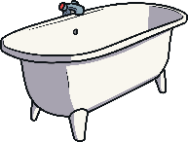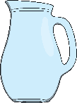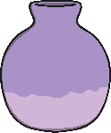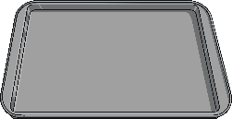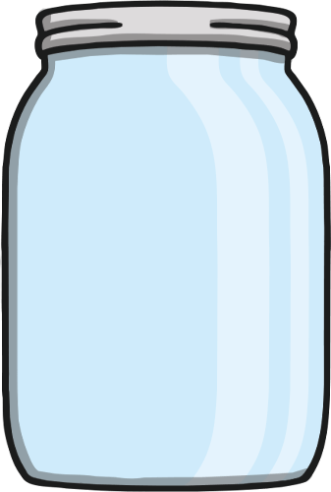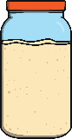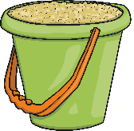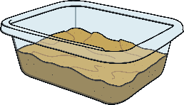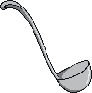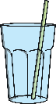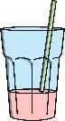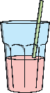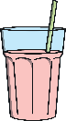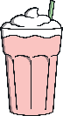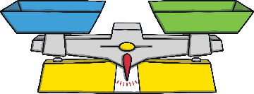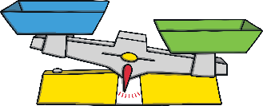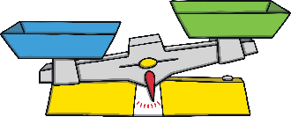

## Capacity

**full nearly full half full nearly empty empty**

**most greater more less least**  
Talk about the size and shape of these containers.

Use some of these words: **tall thin   narrow   wide   shallow   deep**

Which container do you think might hold the most?

Compare the contents of each container.

Look at how many ladles it took to fill each container. Which container has the greatest capacity? Then, order them from smallest capacity to the greatest.

## Mass

**heavy heavier than heaviest light lighter than lightest**

**equal to balanced**

Talk about what these balance scales show.

Bigger items are not always heavier. Smaller items are not always lighter.

Which item is the heaviest? Which is the lightest? How do you know? Put the items in order of lightest to heaviest.

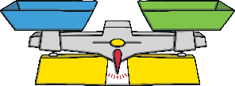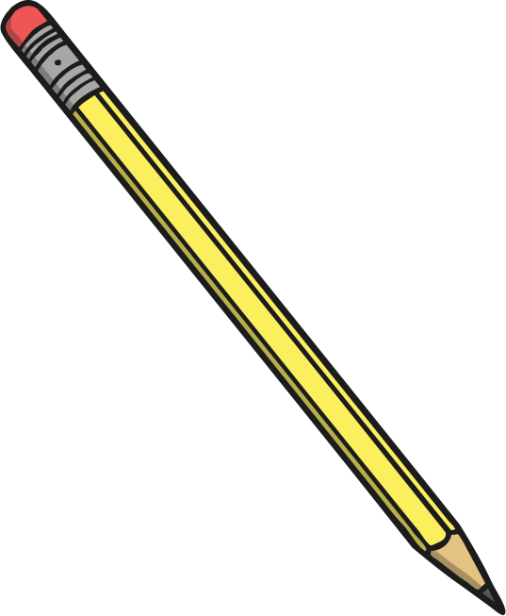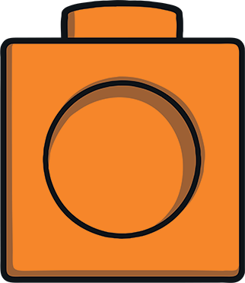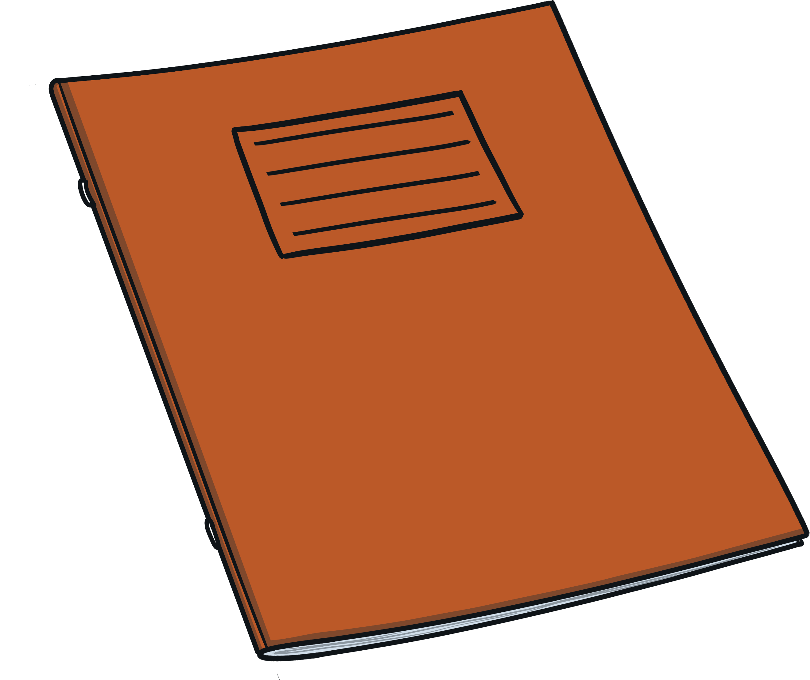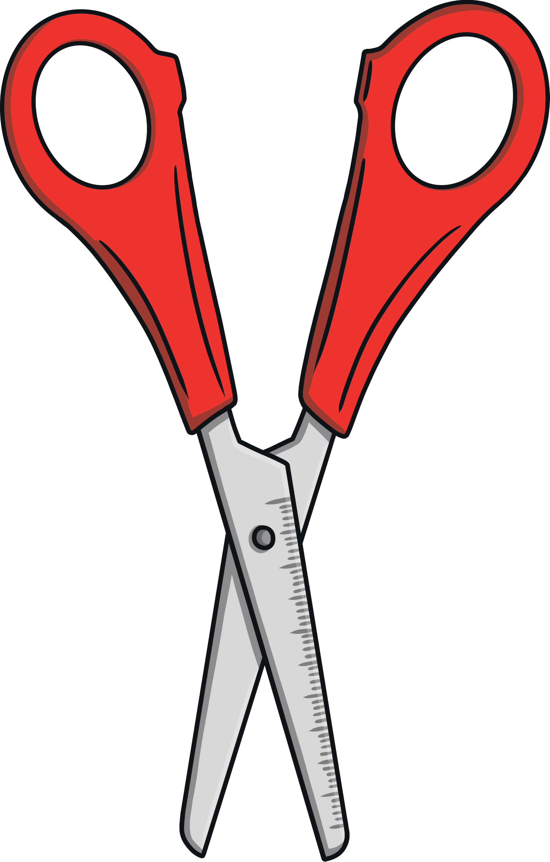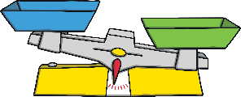

**Challenge Yourself:**

* Select a cup. Count how many tablespoons it takes to fill your cup. Now, see how many teaspoons it takes. Which spoon was the quickest to fill the cup?
* Fill an empty jar with water. Then, find a container that holds more than your jar and another container that holds less than your jar.   
  Empty the water from your jar into the containers   
  to check.

**Challenge Yourself:**

* Hold and compare the weight of different packages of items from around the house (e.g. cereal box, shoebox, bag of sugar). Which box feels the heaviest? Which box feels the lightest? Are bigger boxes always the heaviest?
* Make a boat out of some junk-modelling materials. Will it float in a sink of water? What happens when you add some passengers to the boat? Maybe your boat will sink. Why?

### Maths Talk and Learn: Supporting White Rose Maths Mass and Capacity