Reception Autumn 2 Curriculum Overview
Sparking an interest in: Traditional Tales Big Question: What are traditional Tales?
The following is a summary of the focused activities we will be carrying out this term in addition to child initiated learning.
Texts we may read this term
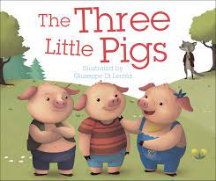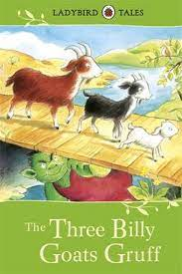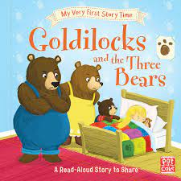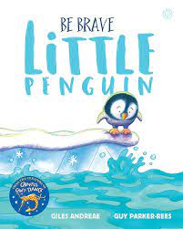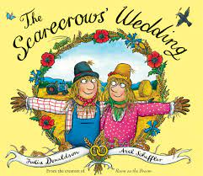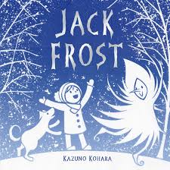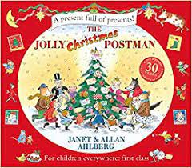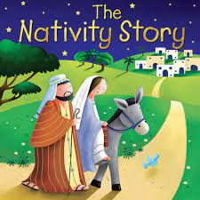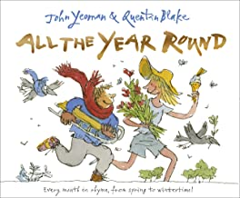

Physical Development

This term we will start gymnastics. We will begin to negotiate space and obstacles safely; with consideration for ourselves and others. We will demonstrate strength, balance and co-ordination and move energetically, such as running, jumping, hopping, skipping and climbing.
We will move on apparatus in different ways, learning how to balance and then jump off the apparatus. We will learn how to create shapes with our body and roll.
We will also start our first dance unit. We will begin to create dances and work with a partner.
We will listen carefully to music and experiment with moving in different ways, at different levels and dancing in different directions. Once we have learnt different dances and experimented, we will perform our dances to our peers.

Personal, Social and Emotional Development
This term we will continue to develop friendships, working on understanding different points of view and challenging our own and others’ thinking.

We will be proactive in seeking adult support articulating our wants and needs when having a clear idea about what we want to do in our play.
We will recognises that we belong to different communities and social groups and we will communicate freely about own home and community.

We will attempt to repair a relationship or situation where we have caused upset and understand how our actions impact other people.
Communication and Language
This term we will focus on traditional tales and developing a deeper familiarity with the texts. We will retell the stories through role play and story mapping in our own words.
We will articulate our ideas and thoughts in well-formed sentences, discussing topics of interest during our focus week and sharing our ideas with our friends.
We will ask questions to find out more about traditional tales and our topics such as Diwali and winter and begin to answer more ‘Why’ and ‘How’ questions.
We will continue to development our vocabulary, learning new words linked to our topics.
We will begin our ‘Drawing Club’ where we will engage in new texts, learning key new vocab with actions and ask I wonder questions through drawing and writing.

R.E
Big Question: Why do Christians perform Nativity plays at Christmas?
This term we will be learning about the traditions of Christmas. We will learn about baby Jesus and how and when we celebrate his birthday. We will learn about Advent and why this is important to Christians. As part of RE this term we will also perform a nativity, retelling the story of Christmas.
As well as learning about Christmas we will learn that other faiths have celebrations as well focusing on the Hindu celebration of Diwali. We will learn about special places that are important to others such as Church or a Temple. We will that people have different beliefs and celebrate special times in different ways.

Literacy
This term we will continue to learn new sounds and words. We will begin to read some high frequency words, and to use developing knowledge of letters and sounds to read simple phonically decodable words and simple sentences.
We will engage with books and other reading materials at an increasingly deeper level, sometimes drawing on our phonic knowledge to decode words and use our knowledge of language structure, subject knowledge and illustrations to interpret the text that we are sharing.
We will describes main story settings, events and characters in increasing detail and act out stories in our play.
For our writing we will developing our phonic knowledge to write. This will enable us to enjoy creating texts to communicate meaning for an increasingly wide range of purposes, such as making greetings cards, tickets, lists, invitations and creating our own stories and books with images and sometimes with words, in print and digital formats.
Phonics - Level 2 - ck, e, u, r, h, b, f, l, ll, ff, ss,
Tricky Words - I, go, to , no, the

Mathematics
This term we will start our topics ‘It’s Me 1,2,3’, ‘Circles and Triangles’, ‘1, 2, 3, 4, 5’ then move on to ‘Shapes with 4 sides’. During these topics we will focus on numbers 1 - 5. We will represent, compare and look at the composition of each number. Learning that numbers are made up of smaller numbers and focussing on number bonds to 5. As we learn to count and compare, we will explore one more and one less. To support our learning we will use counting frames. We will explore shape with a focus on triangles, circles and 4 sided shapes using Kandinsky art to support our learning. We will explore positional language, identifying where objects are positioned and begin to create maps to represent places of importance. We will begin to measure time in simple ways, describing when events happen, using timers and discussing times of the day.
We will use the traditional tales to support our learning as well as stories such Peace at last, Bear in a square and NumberBlocks.

Expressive Arts and Design
This term we will use our topics to create pictures linked to Bonfire night, exploring colour and texture to express what we could see an hear. During Diwali we will make Divas using different techniques. We will share our creations, explaining the process we have used and why we have used certain colours and techniques.
We will make use of props and materials when role playing characters in narratives and stories, playing cooperatively as part of a group sharing ideas. We will be retelling the story of the texts we have read. Taking on different roles within the stories and creating our own parts.
We will be learning new songs for our Christmas performance and begin to work together to perform a show to our families.
We will explore music in a range of ways, playing with sounds creatively, playing along to the beat of the song we are singing or music we are listening to.

Understanding the World
This term we will explore bonfire night, learning about the past history and what we do in the present day to remember.
We will talk about past and present events in our own life when sharing stories during circle times.
We will remember and talk about significant events in our own experiences and compare those of others.
We will begin to use the Ipads to complete simple programs and explore the internet using safe websites supported by an adult. We will learn about internet safety and the importance of age appropriate games.
We will use our senses to explore the seasonal changes with Autumn and begin to explore different materials.

School Values
Our school values this term are Courage and Love. As we explore the value of courage we will learn about Remembrance day and the importance of the poppy. We will question What does courage mean? We will share books about courage and discuss times when we have felt brave.
As we explore the value of Love, we will explore what love means. Children will share what love means to them and how it makes them feel. We will read the story ‘The Scarecrows Wedding’ and talk about special times in their families.

