Reception Autumn 1 Curriculum Overview
Sparking an interest in: All about me Big Question: What makes me unique?
The following is a summary of the focused activities we will be carrying out this term in addition to child initiated learning.
Core Texts this term
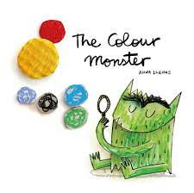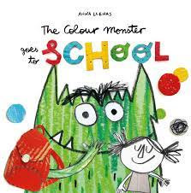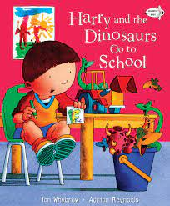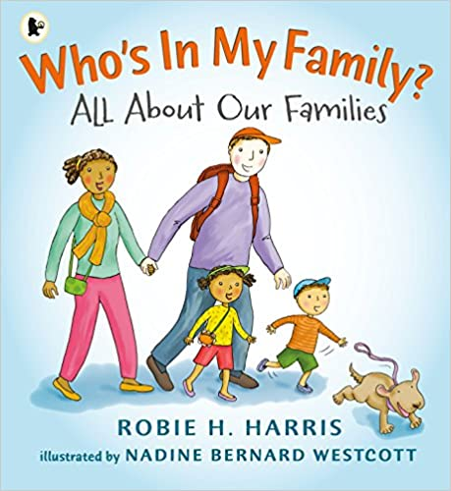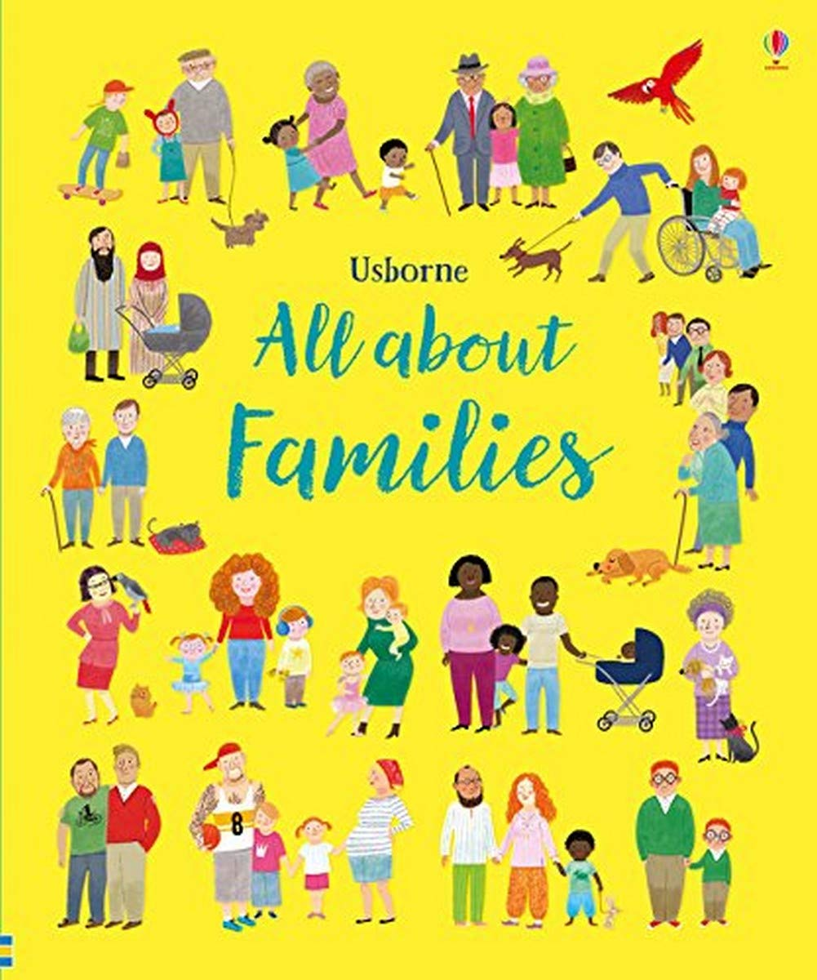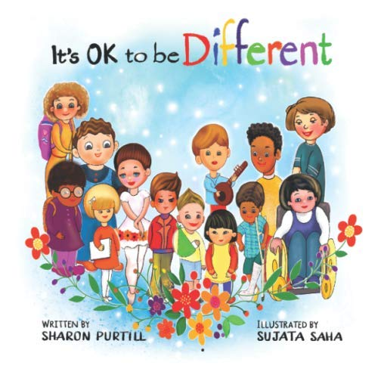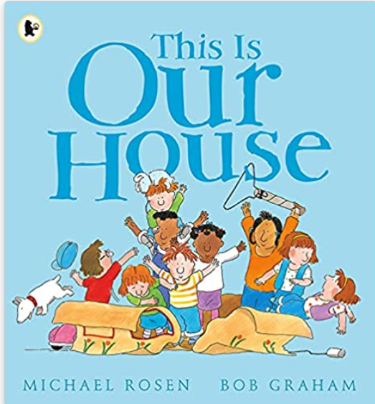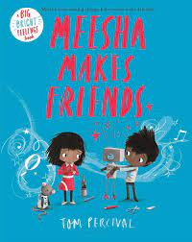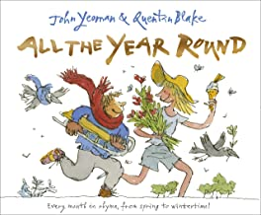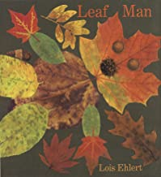

Physical Development
This term in PE our topic focus is ‘Autumn’. During this topic we will learn how to run skilfully and negotiate space successfully, adjusting our speed or direction to avoid obstacles. We will experiment with different ways of moving around the hall and on small apparatus. We will begin to show increasing control over an object in pushing, patting, throwing, catching or kicking it.
We will practice lining up and queuing at mealtimes and getting ready to go outside by putting on our coats independently.
We will have outdoor physical activity daily, encouraging large gross motor movements. We will use big and small motor movements with pencils, big paintbrushes and chalks. We will practice riding safely on the scooters and bikes outside, developing our balance
We will have daily playdough to help practice squashing, patting and moulding, developing our fine motor skills.
Personal, Social and Emotional Development
We will be settling into our new class, spending time exploring and familiarising ourselves with our new environment.
We will be creating rules as a class and learning the routines of the school day as we develop a sense of responsibility. We will begin to try new activities, selecting our own resources and sharing with our peers. We will participate in turn taking games and learn to work cooperatively with others. We will listen to the Colour Monster to help understand our feelings.
We will begin to build constructive relationships, listening to each other, showing kindness and making new friends.
Communication and Language
This term as we settle into our new classroom we will listen to stories and talk about what happened. We will Read stories about going to school such as ‘Harry and the Dinosaurs Go to School’ to help us settle into school.
We will sing familiar songs and begin to learn new ones.
We will be playing games to help learn to recognise our names and to learn the names of the other members of Sycamore Class.
We will begin to understand how to listen carefully and why it is important. We will listen to and follow new instructions in our daily routines.
We will spend time talking about ourselves and listening to others, sharing our likes and dislikes and learning all about our peers.
We will share our experiences, talking about events and people that are important to us.

R.E
Big Question: Why is the word ‘God’ so important to Christians?
This term we will be learning about Christianity. We will learn about the word ‘God’ and why god is special to Christians. We will learn about the creation story, understanding why we need to look after our world and how to make it a better place. We will learn about how the Church is a Christian place of worship and visit our local church. We will also celebrate the Harvest festival.
We will learn our daily prayers for lunch and the end of the day and begin to join in with Collective worship assemblies in class.

Literacy
As we settle into school we will be engaging in level 1 phonics. We will develop our listening and attention skills as we play different sound games. We will develop our oral blending and segmenting of sounds in words by listening to sounds within words, remembering them in the order in which they occur.
We will begin our phonics programme with phase 1 – developing our listening skills. We will then begin to learn our Level 2 sounds. As we learn new sounds we will begin to blend them together to read simple words.
We will share stories as a class, especially focussed around starting school and feelings. We will discuss key concepts about print as we share stories. We will be looking carefully at our names and learning to write them. As well as forming our new letters as we learn them and applying them in our mark making.
Phonics
Level 1 – Alliteration, rhythm and rhyme, voice sounds and oral blending and segmenting.
Level 2 - s,a,t,p,i,n,m,d,g,o,c,k
HFW: - it, is, in, at, a, an, as, and

Mathematics
This term we start our Topic – Just Like Me! During this topic we will learn how to sort, match, compare and create patterns.
As we begin to match and sort we will share stories such as Monkey Puzzle and The Button Box. We will learn how to match by looking at what is similar using language such as the same and different. As we begin to sort different objects we will learn how to look for similarities and differences and how we can group objects based on their attributes, challenging ourselves by guessing rules for sorting and thinking of our own criteria.
We will then learn about comparing. We will compare by amount, mass, capacity and weight. Exploring new language to help us compare different items, describing how they are different or equal. Using books such as A Squash and a Squeeze and Dear Zoo to help us think about comparing. We will then focus on creating repeating patterns using a variety of objects.

Expressive Arts and Design
This term we will focus on our own uniqueness. We will draw ourselves and our families using shapes and drawing with more detail to represent faces.
We will have a home role play area, where we can take on different roles, developing storylines in our play and re-enacting roles within our family.
We will develop our play with the small world equipment, creating stories and building with different resources.
During music time we will listen to different songs and discuss how we feel and what we can hear. We will begin to explore different musical instruments to express our feelings and ideas. We will take part in musical activities that embed pulse, rhythm and pitch, explore voices and classroom instruments. We will explore high sounds and low sounds using voices and glockenspiels.
We will learn how to use our creative areas, learning how to be independent when selecting different resources to support our ideas and creations.

Understanding the World
This term we will spend time making sense of our own life story and family’s history by sharing photos and memories of ourself with our peers and teachers. We will talk about members of our family and our family structure, learning about the many different families in the world.
We will look at where we live, looking at our local area and our immediate environment, drawing information from simple maps.
We will look closely at seasonal change and observe how the weather is changing and what is happening to the trees, exploring the natural world around them.
We will begin to use the interactive white board to play games to support our learning and explore the beebots.

School Values
Our school values this term are friendship and sharing.
We will be learning about the value of friendship. Listening to stories about friends and sharing making sure we understand how friendship and sharing is important. We will focus on ‘Healthy Me’ this term and begin to understand responsibility in class such as keeping our classroom tidy and safe.

